A step by step guide on how to build an IDM Lookup via API
This is meant for a technical audience and will require an understanding of REST calls and related technologies.
You will need an IONAPI Token to connect to IDM to pull information. Once you have a token, you make a call to the IDM endpoint to pull the document. The method I will present will be the endpoint that allows a search on IDM Attributes for an item. I will present a Preview function that retrieves an image, and the actual item function that downloads the original file.
Steps used to build the API call:
- Log into IDM
- Perform a search for an item in question.
- In our test case, I will search for a Customer Invoice. 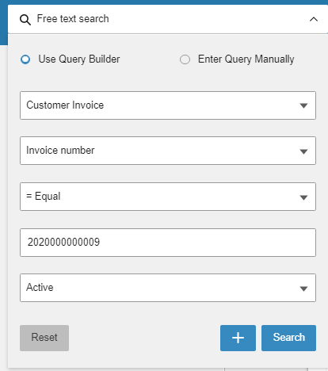
- The search returned the invoice I was looking for. Click on the Invoice Number to view the item in IDM. 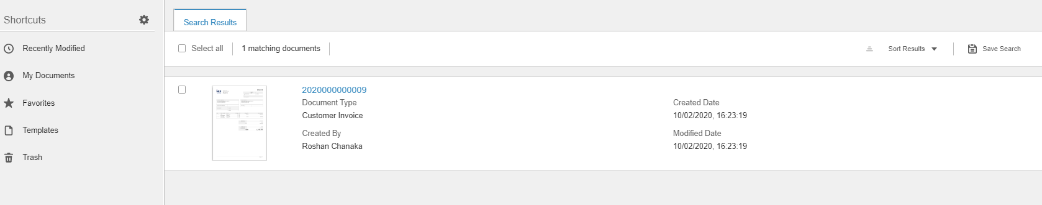
- When we’re going to use the IDM search function, we can only search on attributes that are attached to a document. On the attributes tab, look at the attributes available, and select which ones you’ll use to pull the documents via API later. In this example, we’ll use the Invoice Number.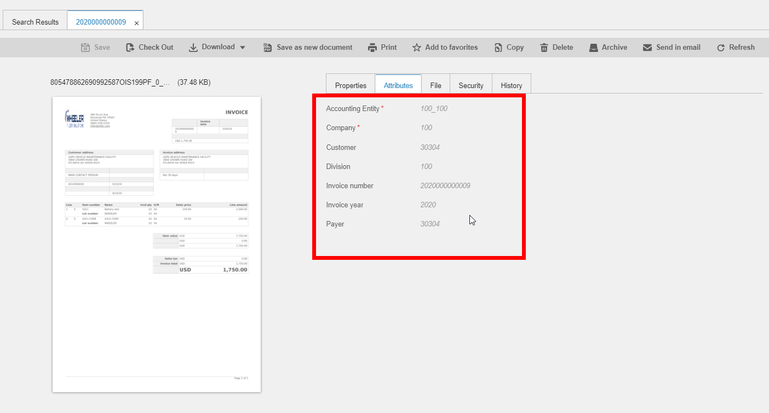

- We need the Document Type internal name to use with the API.
  - Go to the Control Center
  - Click on Administration (1)
  - Click on Document Type (2)
  - Select the Document Type, in our case Customer Invoice (3)
  - Select the General Tab (4)
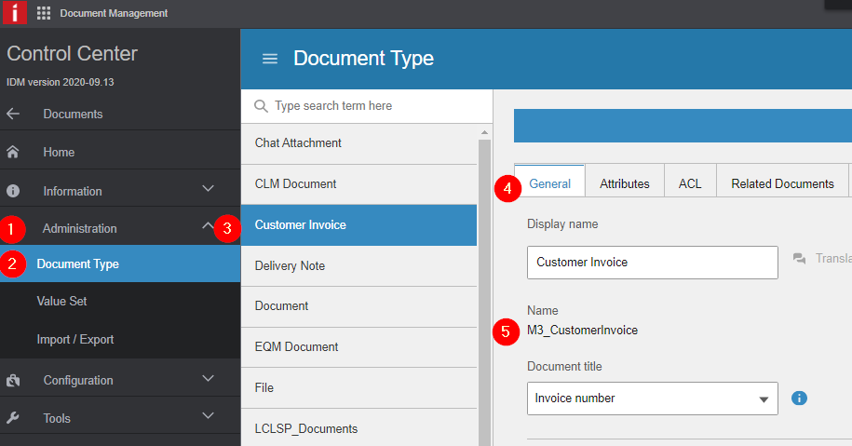
  - Look for the internal name, in this case it’s M3_CustomerInvoice (5) Note that for use with the API.

- Once you’ve selected the attributes to use, we need to find the internal name of that attribute. You do this in the IDM Control Center.
  - Control Center (1)
  - Select Administration (2)
  - Select Document Type (3)
  - Find the Document Type
    - In our case, it’s Customer Invoice (4)
  - Select the Attributes tab for that Document Type (5)
  - Find the attribute, in this case it’s the Invoice Number (6)
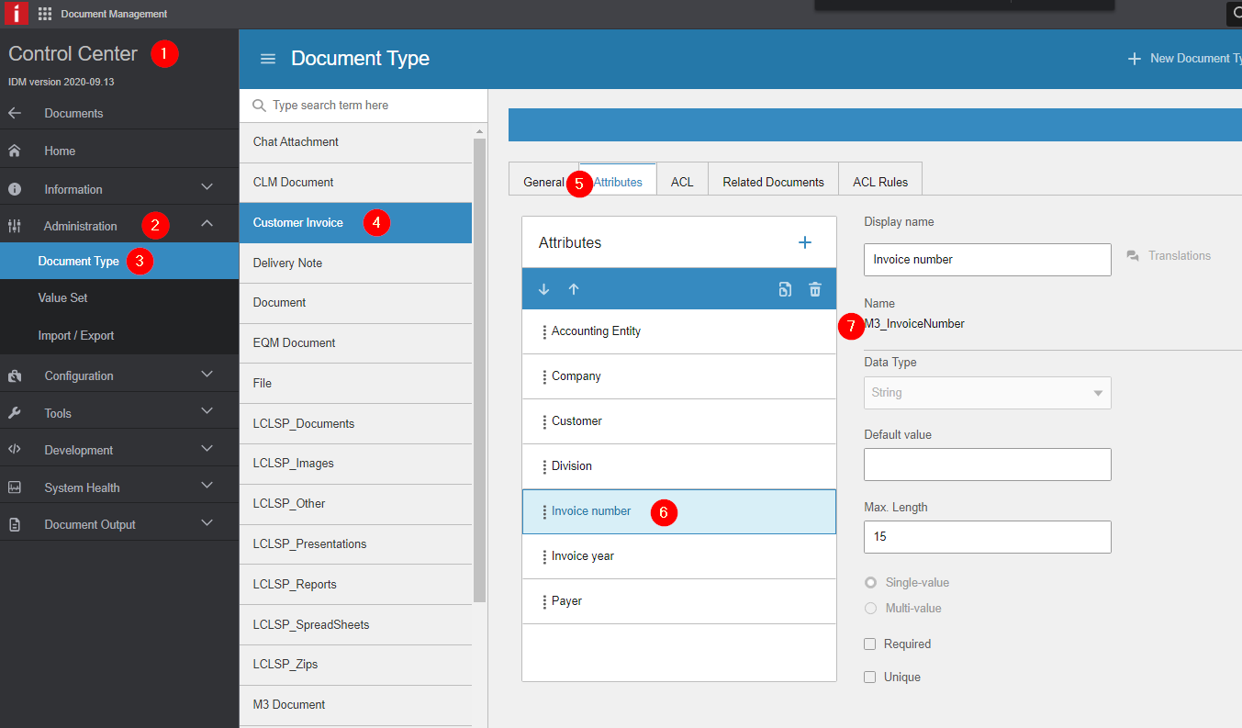
  - The Invoice Number internal name is M3_InvoiceNumber. Note that for use with the API.

To call the API:
You’ll need the IDM Endpoint. You can find this in IONAPI under the list of endpoints. For Wheeler, it’s https://mingle-ionapi.inforcloudsuite.com/<Infor_Envrionment>/IDM.
The beginning of the query is for the document type. Use the internal name we looked up, M3_CustomerInvoice.
- If you add Preview to the URL path, it returns an image preview of the actual document. Remove Preview to return the original document, a PDF in this case.
- M3_CustomerInvoice is the document type, and the first part of the query
- We set the square bracket to show we’re searching on that document type
- The @ symbol is used to specify the attribute, in our case, the Invoice Number, which we looked up the internal name to be M3_InvoiceNumber
- The state parameter limits it to active documents. (0 = Active, 1 = Archived and 2 = Deleted).

URL Parameters assembled:
/api/items/resource/Preview/stream?$query=/M3_CustomerInvoice/[@M3_InvoiceNumber=”222020000000009”]&state=0

The values of the query must be URL encoded:
https://mingle-ionapi.inforcloudsuite.com/<Infor_Envrionment>/IDM/api/items/resource/stream?$query=/M3_CustomerInvoice%5B%40M3_InvoiceNumber=%222020000000009%22%5D&state=0

Sample Call with Curl (Token Pulled off Screen)
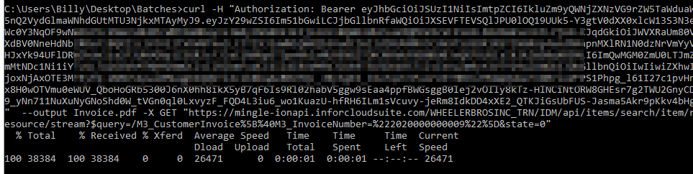
curl -H "Authorization: put token here" --output Invoice.pdf -X GET https://mingle-ionapi.inforcloudsuite.com/<Infor_Envrionment>/IDM/api/items/search/item/resource/stream?$query=/M3_CustomerInvoice%5B%40M3_InvoiceNumber=%222020000000009%22%5D&state=0

Sample Invoice pdf:
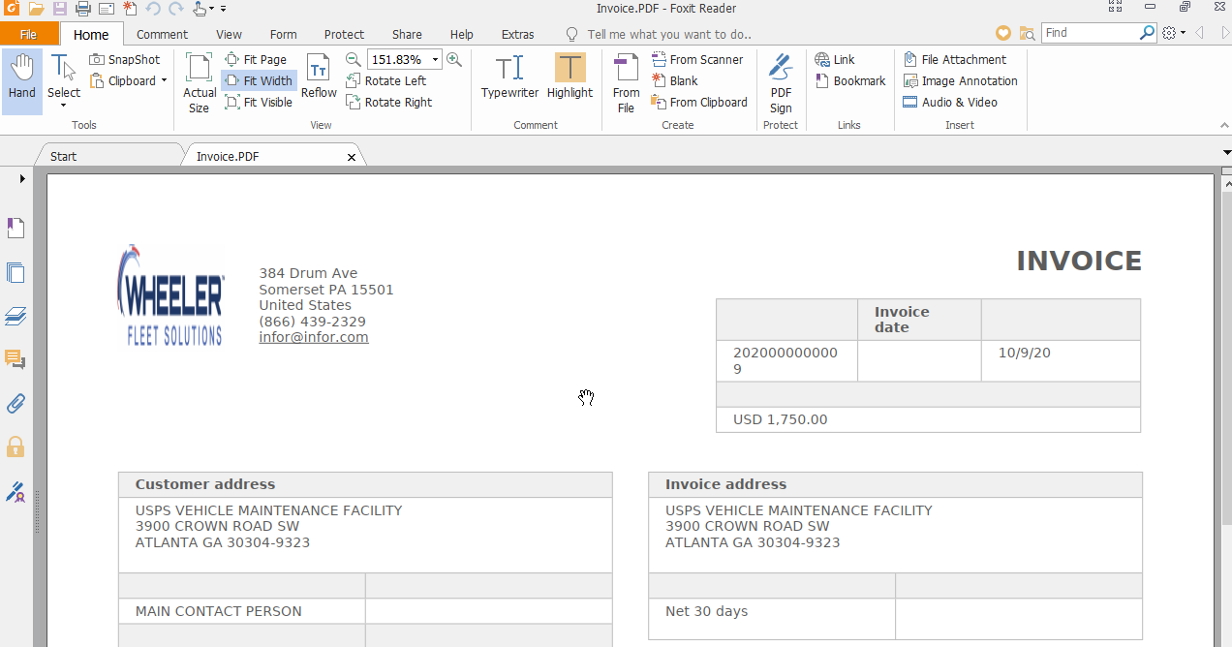

Sample PNG:
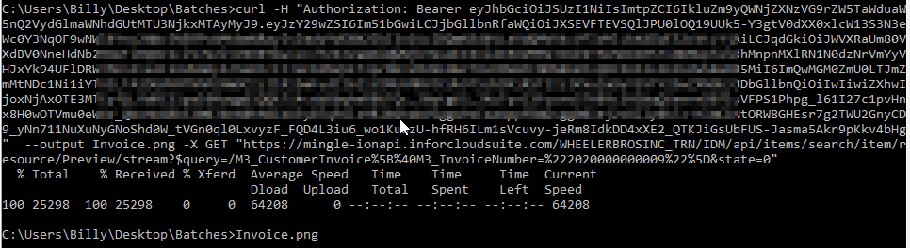

There are other image sizes available, see IDM documentation for details.


